**Forecasting and Clustering**

**Implementing Forecasting**

**Statement:**

Given weather data of past 34 years, use the data from 2011 to 2018 and create a report on rainfall forecast for the year 2019-20.

(Use Weather Data 1984-2018.xlsx Dataset)

**Solution:**

Forecast models capture the evolving trend or seasonality of given data and extrapolate them into future.

Forecast feature of Tableau desktop allows you to forecast quantitative time series data using exponential smoothing model. The exponential smoothing gives more weight to recent observations than older observations.

Let us get started with creating a rainfall forecast report:

**Step 1:** Click on Connect → Microsoft Excel → Weather (1984-2018).xlsx

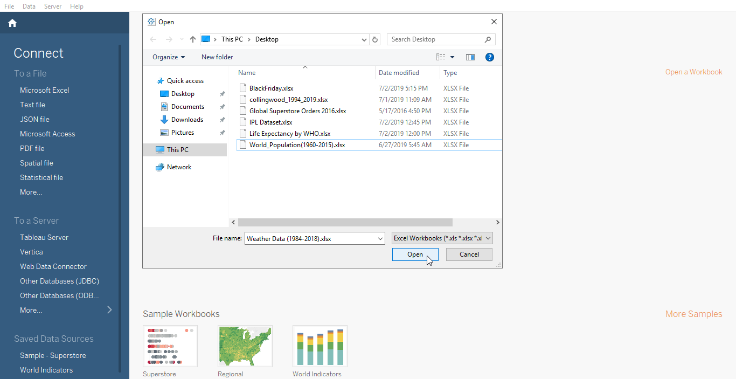

**Step 2:** Drag rag Data to flow pane.

**Step 3:** Sheet 1 → Rename to Rainfall forecast (Optional) → Drag Date to Column shelf and Max Precipitation 10Min (in Mm) to Rows shelf

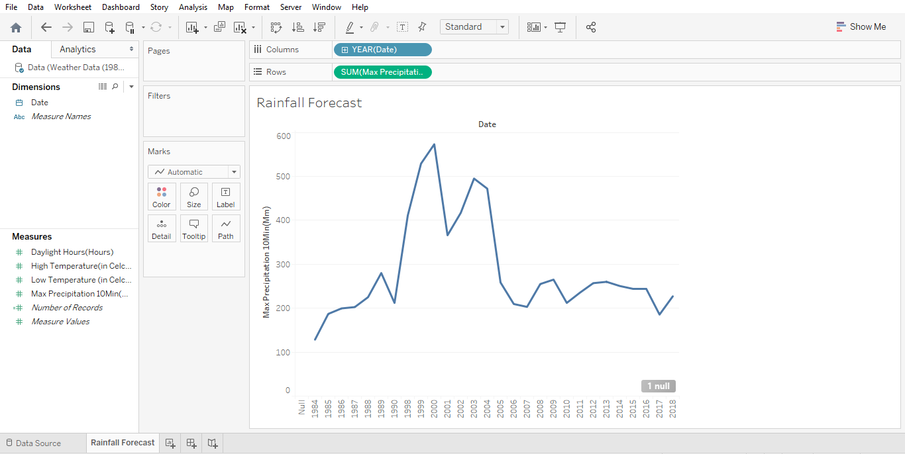

* To analyze the data from 2011 to 2018:

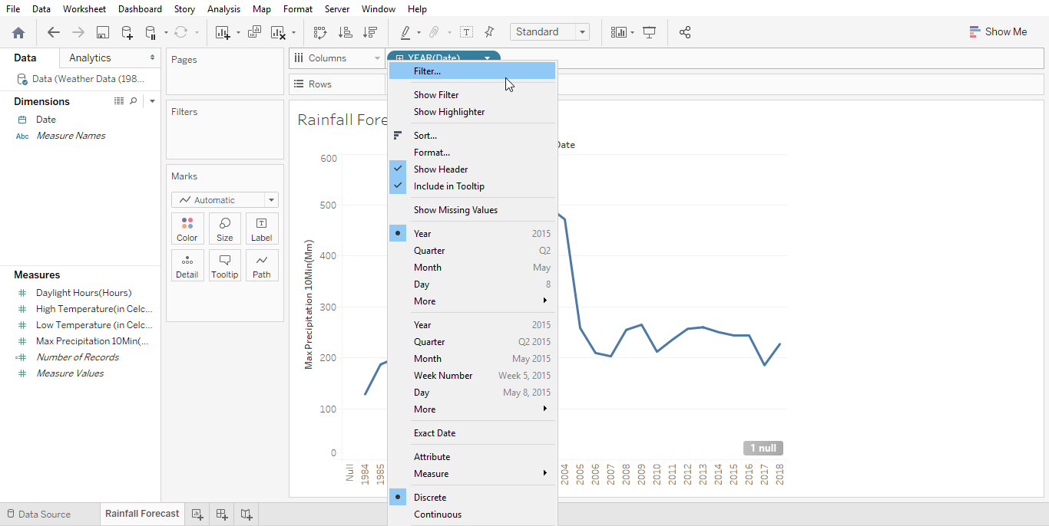**Step 4:** Year → Drop down → Filter → Select from list → 2011 to 2018 → Apply → OK

**Step 5:** Go to Year in Column shelf and change it to month for better visualisation.

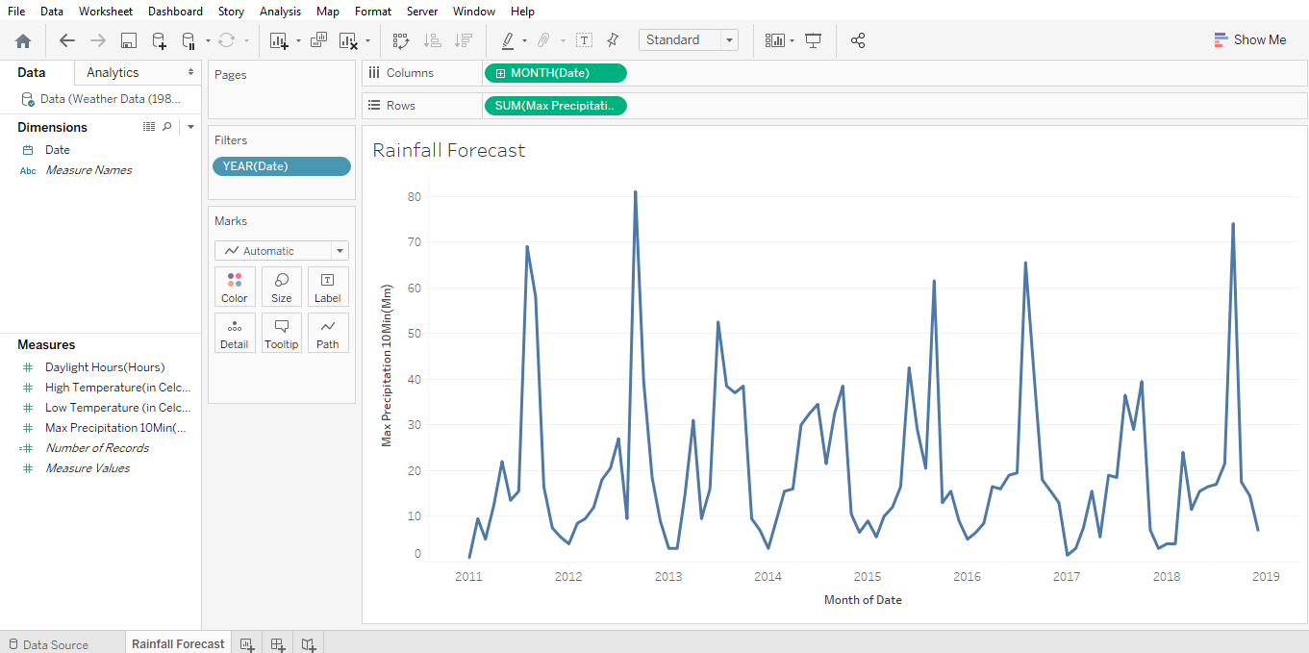

**Step 6:** Data pane → Analytics → Model → Forecast → Drag and drop on view pane

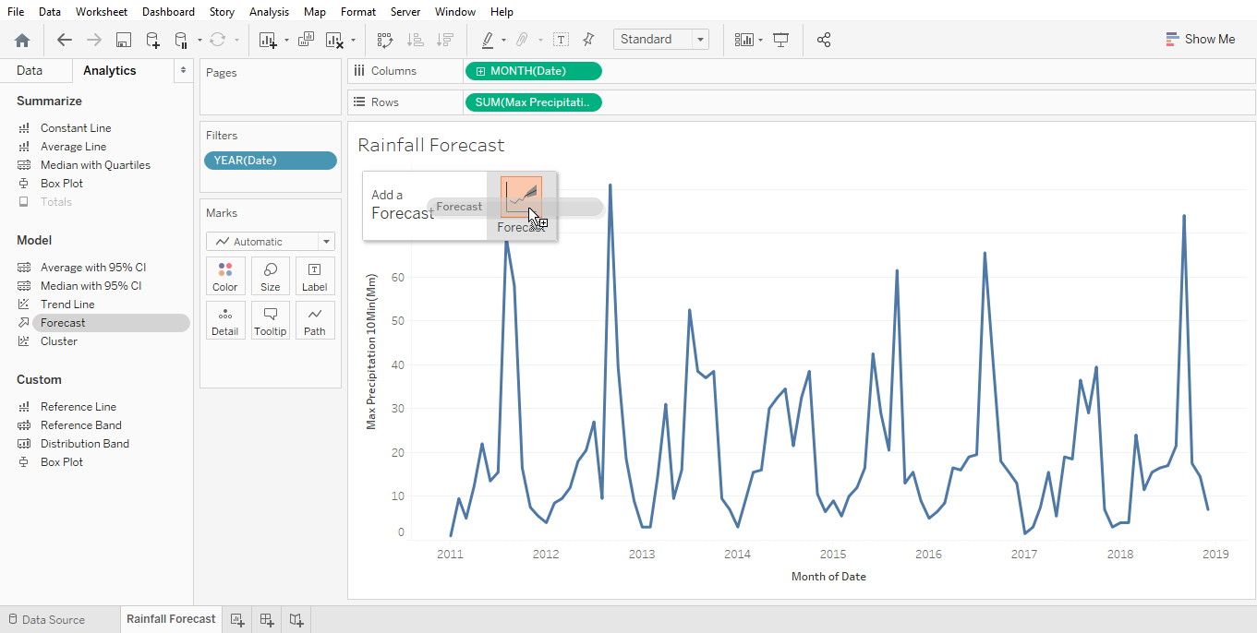

* Forecast for year 2019-20 can be visualized.

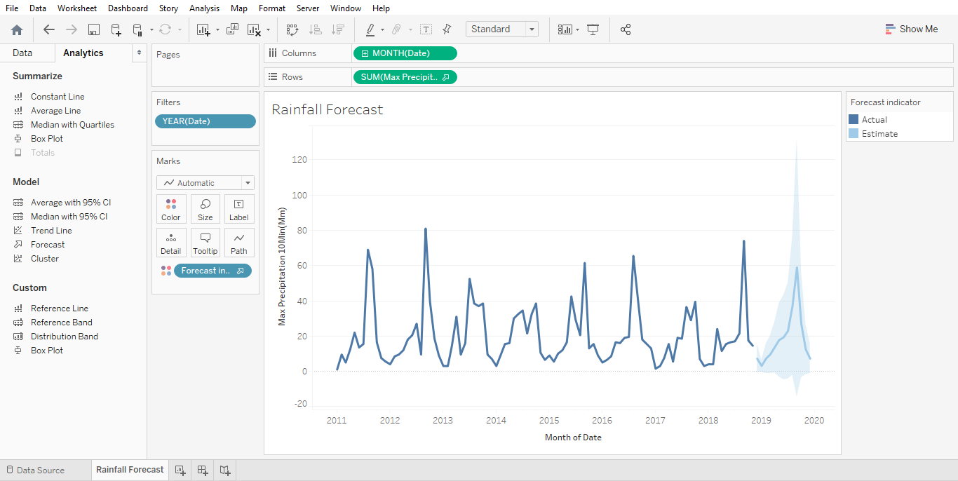

* Form the visualization below, we can forecast that in September 2019 we can expect the highest rainfall

